**WORLD BANK FINANCED**

**LOG IN GEORGIA PROJECT**

**(P169698)**

**ENVIRONMENTAL AND SOCIAL MANAGEMENT PLAN**

**Construction, installation, and activation of broadband infrastructure in Kobuleti (Chakvi direction) and Chokhatauri municipalities**

**September 09, 2021**

**Introduction**

Since 2013, the Government of Georgia has put emphasis on supporting innovation and use of technology across the economy in order to increase the internet access for its citizens and build digital skills among the young people and students. At the same time, the private sector has also played an important role in this regard. Access to the broadband internet has developed steadily over this period of time, with around 67% of the households subscribing to the fixed broadband services. However, when it comes to comparing urban and rural areas, the difference is big. When urban households’ connectivity reaches 83%, this number drops to just 52% for rural areas, wireless network covers most of the households in the rural areas, but the speeds that they provide are not sufficient enough for today’s demands. The government of Georgia’s program for broadband infrastructure development (Open Net Program) aims to address these issues by connecting those rural areas currently underserved by the private sector.

Open Net is a non-entrepreneurial, non-profit legal entity established by the Innovation and Technology Agency of the Ministry of Economy and Sustainable Development (MOESD). Open Net prepared Log-In Georgia Project to be implemented with the World Bank Support.

Log-In Georgia Project is designed to support the government of Georgia’s objectives to extend access to the entire population of the country and integrate citizens of Georgia into the national and global digital economies. Through a combination of funding from the International Bank for Reconstruction and Development (IBRD) and counterpart financing, the Project supports activities in rural areas across Georgia that: (1) extend access to affordable broadband internet services in targeted settlements; and (2) promote its use by individuals and enterprises.

The present site-specific Environmental and Social Management Plan (ESMP) is prepared in agreement with the Environmental and Social Management Framework of the Log-In Georgia Project for works to be undertaken in Kobuleti and Chokhatauri municipalities. If additional risks are identified during detailed design and construction phases, present ESMP will be revised accordingly to reflect them and to prescribe respective measures for mitigation.

ESMP is annexed with the chance finds procedure and a guide to pre-constriction planning for construction contractor as well as the generic occupational health and safety plan, and waste management plan be used by contractor for producing contractor’s ESMP.

**PART A: General Project and Site Information**

|  |  |  |  |  |
| --- | --- | --- | --- | --- |
| **INSTITUTIONAL & ADMINISTRATIVE** | | | | |
| Country | Georgia | | | |
| Project title | Log In Georgia | | | |
| Subproject title | Increasing access to broadband in Kobuleti and Chokhatauri municipalities | | | |
| Scope of site-specific activity | Design, construction, installation, and activation of broadband infrastructure. Site-specific activities include:  -establishing work camps (if needed),  -excavating tranches for optic-fiber cable,  -cable laying,  - horizontal direction drilling (HDD) at paved roads crossing where necessary,  -backfilling trenches,  -installing manholes,  -reinstating right of way.  The corridor of the optic fiber cable will follow the existing state and municipal roads. | | | |
| Institutional arrangements  (World Bank) | Task Team Leader:  Siddhartha Raja | | E&S Specialists:  Darejan Kapanadze (Environmental)  Sophia V. Georgieva (Social) | |
| Implementation arrangements (Ministry of Economy and Sustainable Development of Georgia) | Implementing entity:  Open Net | Works supervisor:  (tbd) | | Works contractor:  (tbd) |
| **SITE DESCRIPTION** | | | | |
| Name of owner and operator of infrastructure to be constructed | National Agency of State Property of the Ministry of Economy and Sustainable Development of Georgia will own the constructed infrastructure and a non-entrepreneurial, non-profit organization Open Net under the Ministry of Economy and Sustainable Development will operate it. | | | |
| Location of infrastructure to be constructed | Kobuleti and Chokhatauri municipalities | | | |
| Who owns the land?  Who uses the land (formal/informal)? | Only national Government owned land and municipal lands will be used for the purpose of Project activities. Upon preliminary screening the installation of fiber-optic cable and any auxiliary inrastructure financed by the project can be accomplished without causing impact on private land or assets.  The land will be screened again by design company for ownership and actual use after the development of detailed design and prior to the beginning of civil works.  Activities that require private land acquisition, land use restrictions, economic losses to affeceted persons, or involuntary resettlement will be deemed ineligible. Therfore, the contractor will seek technical solutions to avoid impacts on private land and assets. If such impacts are unavoidable the contractor will immediately notify Open Net, and impact mitigation and compensaiton measures will be proposed and implemented in accordance with World Bank ESS5. Temporary land use and access needs by the contractor will be negotiated and arranged on a lease basis with the respective private owners. Any accidental damages to private assets, crops, property, etc. will be fully restored or compensated by the contractor. | | | |
| Description of physical and natural environment, and of the socio-economic context around the site | The corridor of optic-fiber cable is located in Kobuleti municipality, Autonomous Republic of Adjara and Chokhatauri municipality, Guria region. In Kobuleti, the cable network connects settlements located on the Kolkheti lowland, whereas in Chokhatauri, the cable connects the villages located both on the Kolkheti lowland and foothills of the north-western part of Meskheti mountain range. The optic-fiber cable route goes up the river Gubazeuli valley as well.  The main topographic features of the region are plains of Kolkheti lowland, foothills, small valleys and ridges of Meskheti mountain range, Lesser Caucasus. Main geomorphological structures are accumulated plain and deeply eroded ridges formed by volcanogenic and sedimentary rocks. Coastal part of Kobuleti municipality is characterized by swampy surfaces and coastal-marine sediments.  Because of the proximity of the Black Sea, the climate of the region is warm and humid, with prolonged rainy weather in coastal areas of Kobuleti (average 2 000 millimeters annually). Kobuleti receives highest amount of precipitations in Georgia, especially westward slopes of Meskheti mountain range. The coastal areas receive most of the precipitation in the form of rain whereas inner (hilly and mountainous) parts are relatively dryer and cold and snowy in winter. The climate in Chokhatauri is warm and humid as well, with mild winter and hot summer in plains. It receives relatively less precipitations than Kobuleti (1 500 -2 000 mm on average annually). In mountainous, eastern part of the municipality winter is longer and snowy.  The region has quite elaborated network of rivers. The rivers are Supsa, Gubazeuli, Choloqi and Kintrishi. They are fed by rain, snow melt and ground water, and characterized by spring floods and winter low waters.  The most widely distributed soil types are alluvial (on rivers’ terraces), red soils, red podzolized soils, yellow brown forest, brown forest acid, brown forest podzolized.  On the lowlands natural vegetation cover mainly consist of temperate rain forests. These areas are transformed by human economic activities and are mostly dominated by anthropogenic landscapes. The western and north-western slopes of Meskheti range is mainly covered by deciduous forests (main species- oriental beech, oak, chestnut, maple, hornbeam), 1 200 m above sea level spruce and fir trees are dominant. Above the tree lines, the mountains are covered by sub-alpine and alpine meadows. [Kobuleti Managed Reserve](https://en.wikipedia.org/wiki/Kobuleti_Managed_Reserve) and [Kintrishi Protected Landscape](https://en.wikipedia.org/wiki/Kintrishi_Protected_Landscape) are located in Kobuleti municipality.  In Kobuleti municipality economy mostly relies on tourism and hospitality industry. In inner areas of the region the soils and climate are favorable for cultivating crops as well. Citrus fruits and tea are leading crops. Livestock rising is also important. In Chokhatauri municipality predominant type of economic activities is agriculture (maize cultivation and animal husbandry). Tourism industry is also growing during last several years. Nabeghlavi mineral water bottling plant is also operating in the region.  There are no known movable/immovable cultural/historical and archaeological sites in the immediate vicinity of the route. | | | |
| Locations and distance for material sourcing, (especially aggregates, water) | There are at least three quarries in Kobuleti and Chokhatauri municipalities that can produce sand and gravel for construction purposes. Distances to be travelled between quarries and the intended broadband cable corridor do not exceed 90 kms. Contractor may opt to apply for an extraction license and open own quarry (ies) if deemed preferable.  below is a list of quarries located in the region:   |  |  | | --- | --- | | **Type of resources** | **Location** | | River gravel quarry | Kintrishi, Kobuleti municipality. | | Gravel quarry | Village Kheghru, Khelvachauri municipality; | | Gravel quarry | Ozurgeti, Ozurgeti municipality; |   Bottled water will be supplied to workers at work sites.  Water for sanitation purposes can be delivered to the construction camps by trucks from local boreholes or from the municipal water network.  Water for the construction purposes can be supplied from the river Supsa, Gubazeuli, Kintrishi, or Chakvistskhali rivers/or from local boreholes. | | | |
| **LEGISLATION** | | | | |
| National & local legislation & permits that apply to project activity | **Law on the Environmental Assessment Code (2017)**  The Code lists out two sets of activities one of which is subject to the Environmental Impact Assessment (EIA) under any circumstances while the other may or may not require EIA, depending on the project-specific decision of the Ministry of Environment Protection and Agriculture (MEPA). The Code introduces screening and scoping phases in the EIA process. It mandates disclosure of documentation generated in the EIA process and public participation in decision-making. Screening applications and conclusions as well as scoping and EIA applications and reports are all subject to disclosure through the web page of MEPA. The Ministry is responsible for advertising and holding public consultation meetings on scoping and EIA reports. The project proponent is responsible for carrying out EIA. Based on the outcome of the EIA process, MEPA issues positive or negative conclusion on the activity under consideration.  *Works to be performed under the Log-in Georgia Project (trenching, cable laying and backfilling activities) are not subject to environmental review by MEPA. However, if the disposal of waste, mining for natural construction materials or any other supplemental activity in the scope and scale above thresholds established in the Code is to be undertaken, contractor will have to apply to MEPA and, depending on the screening outcome, may be required to undertake EIA and obtain positive conclusion of MEPA.*  **Law on the Waste Management Code (2014)**  This Code establishes the legal framework for the management of hazardous and non-hazardous wastes, including minimizing waste generation and maximizing reuse and recycling. The law will require the project to manage all wastes in a way that protects the environment.  *It is expected that construction, installation, and activation of broadband infrastructure will generate less than 200 tons of non-hazardous wastes per annuum, mostly in the form of spoil from excavation and fiber optic cable related waste.*  *Generated waste will be handed over to specialized companies for recycling (if possible) or disposed at approved municipal landfills.*  *If generated waste is more than 200 tons per annuum, the waste management plan will be developed by the construction company and submitted for review and approval by the MEPA as per requirements of national legislation. If more than two tons of hazardous waste is generated, which is not considered to be likely, contractor will have to develop and implement a hazardous wastes separation and collection system and provide information and appropriate training to workers.*  *Generic arrangements for handling, temporary storage, transportation, and final disposal of inert and hazardous waste is provided in the Open Net’s Waste Management Plan attached to this ESMP. This Plan is to be used by contractor for developing Contractor’s ESMP.*  **Law on Environmental Protection (1996)**  The law establishes the main principles of environment protection. Provisions of the law that are relevant to the project include environmental management, licensing, standards, environmental impact assessment, ecosystem protection, protected areas, and biodiversity.  **Law on Soil Protection (1994)**  This law is intended to ensure preservation of soil integrity and improve soil fertility.  *This law requires that during excavation of trenches and pit holes, topsoil is preserved by removing and storing it before using it to reinstate disturbed sites. Fuels and other hazardous substances shall be managed so that they do not contaminate soils.*  *The construction contractor will be also required to follow the requirements of governmental decree on topsoil removal storage, use and re-cultivation, decree #424 31 December 2013.*  **Law on Water Protection (1997)**  The Law regulates water resources in Georgia, including the use and protection of surface and underground water. Project developer is obliged to prepare technical project for extraction of water from any surface water body, which shall be agreed with and approved by the Ministry of Environment and Agriculture of Georgia.  *Construction, installation, and activation of broadband infrastructure will require the use only small quantities of water. There will be no discharges of wastewater or other materials to water bodies, and there will be limited potential for significant impacts on water quality.*  *If work camps are needed and have to be equipped with wastewater treatment units, respective documentation (information on the location, technical capacity, maximum concentration of pollutants) will be developed and submitted to the MEPA for screening and registration.*  **Law on Atmospheric Air Protection (1999)**  This law prohibits human activities that affect air quality and regulates activities that may cause a negative impact on human health or the environment.  *The requirements of this law will be addressed in occupational health and safety plan (dust control measures), community health and safety plan, and traffic management plan to be included in the Contractor’s ESMP.*  **Law on Cultural Heritage (2007)**  This law sets rules for undertaking activities on the objects of cultural heritage and procedures for handling chance finds during excavations.  *Works under Log-In Georgia Project will not have impact on the known cultural assets. However, likelihood of chance finds is present due to the planned earth works. Open Net developed a chance find procedure that requires that works are taken on hold and the Ministry is informed in case a find is encountered. Chance find procedure is attached to this ESMP.*  **Law on Public Health (2007)**  The law establishes rights and obligations related to public health, including the prevention of contagious diseases. To ensure a healthy environment, the Ministry of Internally Displaced Persons from the Occupied Territories, Labor, Health and Social Affairs of Georgia establishes environmental quality standards with which the project must comply, including maximum permissible concentrations and exposure limits for contaminants in air, water, soil, noise, and electromagnetic radiation. The Ministry also is responsible for monitoring compliance with the standards.  **Law on the Labor Code of Georgia (2010)**  This law regulates labor relations between workers and employers. It requires fair reimbursement and the creation of safe and healthy working conditions. The law includes a number of provisions relevant to the project, including employment guarantees, working time, government social insurance, benefits and pensions, age, internal labor regulations (i.e., human resources manual), and occupational health and safety. The law prohibits discrimination based on color, race, sex, sexual orientation, disability, religion, political and social status, and other personal characteristics.  **Law of Labor Safety (2018)**  The law establishes the rules and norms on health and safety in the workplace, safeguarding measures for hazardous professions, obligations of employers and employees, requirements for health and safety trained staff within each enterprise, the procedures for state inspection of health and safety, and process for remedial actions and penalties for noncompliance. The Labor Inspection Department of the Ministry of IDPs, Labor, Health and Social Affairs (MoILHSA) is in charge of enforcing this law.  *The requirements of law on Public Health, Labor Code of Georgia and Labor Safety Law of Georgia will be applied at both the construction and operation phases and are incorporated in the occupational health and safety plan attachment to this ESMP. Construction works will be conducted in accordance with the provisions of these Law as well as all related procedures and principles. Contractor will be required to develop and submit for approval community health and safety pan, code of conduct, labor management procedure and occupational health and safety plan before the commencement of construction works. Construction contractor shall conduct training for workers, provide them with necessary personal protective equipment and safe working conditions as well.*  **Law on the Civil Code of Georgia (1997)**  The Civil Code of Georgia regulates private civil relationships, and it evolves property rights, the law of obligations, family law and the law of inheritance.  **Law on the Rules for Expropriation of Ownership for Necessary Public Need (1999)**  The aim of this Law is to determine rules of granting the right to expropriation for public needs and rules of implementing expropriation. Expropriation for pressing public needs may be effected on the basis of an Order issued by the Minister of Economy and Sustainable Development of Georgia (hereinafter, “the Minister) and a court decision, in favor of a State body, a local self- governance body, a public law entity or a private law entity, which has been granted the Right to Expropriation under this Law.  **Government Decree N134 04.07.2007 on Protecting linear structures of electronic communication networks and defining their protection zones.**  This act defines the protection zones for different types of electronic communication lines and sets number of restrictions for construction and other activities (including activities by landowners) in such zones without the permit of the owner of certain line.  **Public Registry Instruction (Order of the Ministry of Justice of Georgia – 31.12.2019, N487).**  4th and 10th paragraphs of Article 15 of this document set the regulation, that the linear structures (e.g. electronic communication networks), including Open Net’s ones, are subjects of property rights that are independent form property rights on the plot itself. Thus: this regulation, in case the cable is to be deployed in the private land plot, prevents the need of obtaining property rights on such land plot by the cable owner, as servitudes would be enough for such situations.  *Requirements of national legislation (and the World Bank’s Social Standards as well) pertaining resettlement are reflected in Project Resettlement Policy Framework (RPF) of Log In Georgia Project.*  *If resettlement need is revealed upon delivery of the detailed design, procedures defined in the RAP will be followed. Resettlement Action Plans (RAPs) will be developed and implemented before the commenced of the construction works. No civil work can start at the section before a RAP is implemented and compensation is paid.* | | | |
| **GRIEVANCE REDRESS MECHANISM** | | | | |
| Grievance redress mechanism (GRM) will be available to allow project-affected persons (PAPs) and construction workers appealing any action or decision on which they disagree.  PAPs will be informed about the available GRM during public consultations and through distributing of brochures prior to commencement of works. In addition, a banner with relevant information will be displayed in accessible and visible locations each and every project-affected municipality and near contractor’s camps and/or construction sites. The design of such banners will be provided by Open Net. The printing, installation and maintenance of such banners in all sites and throughout the duration of works will be responsibility of the contractor. Banners should include full information and contact details of the project GRM including contractor, supervisor, local government and ON focal points. PAPs will be fully informed of their rights and of the procedures for addressing complaints either verbally or in writing during pre-contraction, construction, and operation periods. Care will always be taken to prevent grievances rather than going through a redress process.  **Grievance Focal Point (GFP) in supervision company: TBD**  Social specialist of supervision company will serve as Grievance Focal Point (GFP) to file the grievances and appeals. He/she will be responsible to coordinate with relevant departments/organization and persons to facilitate addressing these grievances. If the issue cannot be resolved at the Supervision company level within 7-14 working days, then it will be escalated to the Open Net.  **Grievance Focal Point in Open Net:**  **Giorgi Lebanidze –** Environmental and social consultant.  Mobile Phone – 577 727 884, e-mail: glebanidze@opennet.ge  If Open Net decision fails to satisfy the aggrieved PAPs, they can pursue further action by submitting their case to the appropriate court of law (Rayon Court) without any reprisal. | | | | |
| **PUBLIC CONSULTATION** | | | | |
| When / where the public consultation process will take /took place | The draft ESMP document will be disclosed in English and Georgian languages through the web page of Open Net. Information will be also posted at the public spaces in administrations of respective municipalities (Kobuleti and Chokhatauri). Local telecom operators will be communicated as well.  Public consultation on the draft ESMP will take place before the commencement of design phase of the project and virtual meeting will be organized through the webex link (or through alternative source) by the Open Net.  Meetings will inform local communities and other stakeholders on the scope and nature of the planned works, expected positive and negative environmental and social impacts at the construction and operation phases, respective remediation measures and the Grievance Redress Mechanism (GRM) to be made available for their use during construction works. Meeting participants will be given opportunity to provide their feedback, questions and comments.  Minutes of the consultation meetings will be developed including record of presentations, comments, questions and answers, photos, copies of participants’ sign-up lists and other supporting documentation. ESMP will be finalized based on the outcomes of the meetings and public feedback. Minutes of consultations are attached to the present version of ESMP. | | | |
| **ATTACHMENTS** | | | | |
| Attachment 1: Site plan / photo  Attachment 2: Health and Safety Management Plan of Employer  Attachment 3: Waste Management Plan of Employer  Attachment 4: Chance Find Procedure  Attachment 5: Guide to Pre-construction Planning for the Provider of Civil Works  Attachment 6: Minutes of Public Consultation Meeting on the draft ESMP | | | | |

**PART B: safeguards information**

|  |  |  |  |
| --- | --- | --- | --- |
| **ENVIRONMENTAL /SOCIAL SCREENING** | | | |
| Will the site activity include/involve any of the following? | **Activity/Issue** | **Status** | **Triggered Actions** |
| 1. Building rehabilitation | [ ] Yes [X ] No | If yes, see Section **A** below |
| 1. New construction | [X] Yes [ ] No | If yes, see Section **A** below |
| 1. Individual wastewater treatment system | [ ] Yes [X] No | If yes, see Section **B** below |
| 1. Historic building(s) and districts | [X] Yes [ ] No | If yes, see Section **C** below |
| 1. Acquisition of land[1] | [ ] Yes [X] No | If yes, see Section **D** below |
| 1. Hazardous or toxic materials[2] | [X] Yes [ ] No | If yes, see Section **E** below |
| 1. Traffic and Pedestrian Safety | [X] Yes [ ] No | If yes, see Section **F** below |
| 1. Impacts on the use land and property | [X] Yes [ ] No | If yes, see Section **G** below |
| 1. Social Risk Management | [X] Yes [ ] No | If yes, see Section **H** below |

**PART C: Mitigation measures**

|  |  |  |
| --- | --- | --- |
| **ACTIVITY** | **PARAMETER** | **MITIGATION MEASURES CHECKLIST** |
| **0**. General Conditions | Notification and Worker Safety | 1. Notify local construction and environment inspectorates and communities on the upcoming activities 2. Notify public on the works through appropriate notification in the media and/or at publicly accessible sites (including the site of the works) 3. Acquire all legally required permits for construction and/or rehabilitation 4. Formally agree with Employer that all work will be carried out in a safe and disciplined manner designed to minimize impacts on neighboring residents and environment. 5. Ensure that workers’ PPE complies with international good practice (always wear hardhats, as needed masks and safety glasses, harnesses and safety boots) 6. Appropriately signpost construction site to inform workers on key rules and regulations. |
| **A.** General Rehabilitation and /or Construction Activities | Air Quality | 1. Suppress dust during pneumatic drilling/wall destruction by ongoing water spraying and/or installing dust screen enclosures at site 2. Keep the surrounding environment (sidewalks, roads) free of debris to minimize dust 3. Disallow open burning of construction / waste material at the site 4. Disallow excessive idling of construction vehicles at sites |
| Noise | 1. Limit construction noise to daytime unless extreme urgency. Notify local communities on the works schedule if it deviates from standard working hours 2. Ensure that during operation, engine covers of generators, air compressors and other powered mechanical equipment are closed, and equipment placed as far away from residential areas as possible |
| Water Quality | 1. Establish appropriate erosion and sediment control measures such as e.g. hay bales and / or silt fences to prevent sediment from moving off site and causing excessive turbidity in nearby streams and rivers. |
| Waste management | 1. Identify waste collection and disposal pathways for all major waste types expected from demolition and construction activities 2. Separate mineral construction and demolition wastes from general refuse, organic, liquid and chemical wastes by on-site sorting and stored in appropriate containers. 3. Collect construction waste and dispose properly to the designated locations 4. Whenever feasible, reuse and recycle appropriate and viable materials (except asbestos) |
| **B**. Individual wastewater treatment system | Water Quality | 1. Ensure that the approach of handling sanitary wastes and wastewater and the design of the treatment system is approved by relevant authorities 2. Ensure that before discharging into receiving waters, effluents from individual wastewater systems are treated in order to meet the minimal quality criteria set out by national guidelines on effluent quality and wastewater treatment 3. Undertake monitoring of newly established wastewater treatment systems and report to Employer on the monitoring outcome 4. Wash construction vehicles and machinery only in designated areas where runoff will not pollute natural surface water bodies. |
| **C**. Cultural Heritage sites /buffer zones | Cultural Heritage | 1. If the cable ducks or shelters will be arranged within buffer zone of cultural heritage site, prior consent of the Ministry of Education, Science, Culture and Sport should be obtained. all construction activities are planned and carried out in line with local and national legislation. 2. Acquaint personnel with the procedures for handling chance finds. Take all physical activity on hold if a change find is suspected or reported by staff and immediately notify Employer in writing. Do not resume work until formal notice from the Employer. |
| **D**. Acquisition of land | Land Acquisition Plan/Framework | 1. If expropriation of land was not expected but is required, or if loss of access to income of legal or illegal users of land was not expected but may occur, immediately consult Open Net and the World Bank’s Task Team Leader 2. Make sure not to enter a subproject site and not to start any physical activity in it prior to receiving formal notice on the completion of resettlement and full delivery of compensation to the affected people |
| **E**. Toxic Materials | Asbestos management | 1. If asbestos is located on the subproject site, mark it clearly as hazardous material 2. When possible, appropriately contain and seal asbestos to minimize exposure 3. Treat asbestos prior to removal (if removal is necessary) with a wetting agent to minimize asbestos dust 4. Handle and disposed asbestos using skilled & experienced professionals 5. If asbestos material is being stored temporarily, securely enclosed it inside closed containments and mark appropriately. Take security measures against unauthorized removal from the site 6. Do not reuse the removed asbestos |
| Toxic / hazardous waste management | 1. Temporarily store all hazardous or toxic substances on site in safe containers labeled with details of composition, properties and handling information 2. Place containers of hazardous substances in leak-proof containers to prevent spillage and leaching 3. Transport waste to official landfills and dispose excess excavated material at sites agreed with the local authorities. 4. No not use paints with toxic ingredients or solvents, or lead-based paints |
| **F.** Traffic and Pedestrian Safety | Direct or indirect hazards to public traffic and pedestrians by construction  activities | * 1. Signpost, place warning signs, arrange barriers and traffic diversions so that the work site is clearly visible, and the public is warned of all potential hazards   2. Establish traffic management system and conduct staff training, especially for site access and near-site heavy traffic. Provide safe passages and crossings for pedestrians where construction traffic interferes.   3. Adjust working hours to local traffic patterns, e.g. avoid major transport activities during rush hours or times of livestock movement   4. Actively manage traffic if required for safe and convenient passage for the public. |
| **G**. Impacts on land property and use | Limited/lost access to the land | 1. Ensure provision of undisturbed and safe access to homes, lands and other assets of the local population; 2. Plan road works to maintain undisturbed access to land and assets of the local population by planning and implementing works and activities in coordination with residents and representatives of the local community. |
| Temporary impact on privately-owned assets | 1. Avoid trespassing or incidentally damaging of private property (using small-size machinery or manual labor near walls and fences, stockpiling of construction material and waste away from private property; etc.); 2. In case of unintended damage to private property, quickly restore it to the original or better status; 3. In case of expected temporary impact on privately-owned property, inform owners upfront and guarantee restoration, acquire written consent of owners for intervention, and promptly restore the damage to the original or better status; 4. If an unexpected need for land take emerges in the course of works, do not enter the affected site prior to development and full implementation of the Resettlement Action Plan. |
| Loss of income or assets caused by unauthorized intervention, occupation of territory outside the right of way (ROW) | 1. Avoid unauthorized intervention of territory outside of ROW; 2. If such impact occurs by negligence of the construction company workers, record the case/claim; assess the loss and negotiate with an affected owner based on the adopted principles and valuation methodology described in the RAP and provide fair cash compensation at the Company’s own cost; 3. Apply GRM procedures if the case is unresolved through negotiation. |
| **H.** Social Risk Management | Public relationship management | 1. Assign local liaison person within Contractor’s team to be in charge of communication with and receiving requests/ complaints from local population. 2. Consult local communities to identify and proactively manage potential conflicts between an external workforce and local people. 3. Raise local community awareness about sexually transmitted disease risks associated with the presence of an external workforce and include local communities in awareness activities. 4. Inform the population about construction and work schedules, interruption of services, traffic detour routes and provisional bus routes, blasting and demolition, as appropriate. 5. Limit construction activities at night. When necessary ensure that night work is carefully scheduled, and the community is properly informed, so they can take necessary measures. 6. At least five days in advance of any service interruption (including water, electricity, telephone, bus routes), advice community through postings at the work site, at bus stops, and in affected homes/businesses. 7. Address concerns raised through Grievance Redress Mechanism established by the Employer within the designated timeline within the scope of Contractor’s liability 8. To the extent possible, do not locate work camps in close proximity to local communities   (i) Undertake siting and operation of worker camps in consultation with neighboring communities |
| Labor management | 1. Recruit unskilled or semi-skilled workers from local communities to the extent possible. Where and when feasible, worker skills training, should be provided to enhance participation of local people. 2. Provide adequate lavatory facilities (toilets and washing areas) in the work site with adequate supplies of hot and cold running water, soap, and hand drying devices. A temporary septic tank system should be established for any residential labor camp and without causing pollution of nearby watercourses 3. Raise awareness of workers on overall relationship management with local population, establish the code of conduct in line with international practice and strictly enforce them, including the dismissal of workers and financial penalties of adequate scale 4. Immediately inform technical supervisor of works and the employer about any accidents/incidents happening at work sites and/or resulting from any contractual activity of works provider which has resulted in tangible damage to human and/or environmental health, including but not limited to trauma or death at work site, traffic accident, emergency emission/pollution of environment with hazardous substances, etc. |

**PART D: Monitoring Plan**

|  |  |  |  |  |  |  |
| --- | --- | --- | --- | --- | --- | --- |
| **Activity** | **What**  (Is the parameter to be monitored?) | **Where**  (Is the parameter to be monitored?) | **How**  (Is the parameter to be monitored?) | **When**  (Define the frequency / or continuous?) | **Why**  (Is the parameter being monitored?) | **Who**  (Is responsible for monitoring?) |
| **PRE-CONSTRUCTION PHASE** | | | | | | |
| Contractor mobilization to work site | Local communities and authorities are informed about upcoming works;  All permits and licenses are obtained by contractor;  Respective PPE is provided for construction workers;  Workers GRM is established;  Construction site is equipped with appropriate signposts and contractor’s contact information is displayed. | Construction sites | Visual inspection;  Checking of documents | Before commencement of construction works | Ensure awareness of local community of upcoming construction works;  Contractor does not engage in harmful/unlawful activities;  Safety of contractor’s personnel at work site is ensured and risk of worksite accidents is reduced;  Entry of construction site by unauthorized persons is prevented. | Open Net through Technical Supervisor |
| **CONSTRUCTION PHASE** | | | | | | |
| Supply with construction materials | Purchase of construction materials from the officially registered suppliers | Supplier’ and Contractor’s offices | Verification of documents and quality | Arrangements for and delivery of construction materials | Ensure technical reliability and safety of infrastructure | Open Net through Technical Supervisor |
| Purchase of natural construction materials | Purchase of material from the existing suppliers if feasible;  Obtain extraction license by the works contract and strict compliance with the license conditions;  Terrace the borrow area, backfill to the exploited areas of the borrow site, and undertake landscape harmonization;  Excavate river gravel and sand from outside of the water stream, arrange protective barriers of gravel between excavation area and the water stream, and no entry of machinery into the water stream.  Marking of the Quarries with warning signs | Quarries | Checking of documents  Visual inspection | During extraction of materials | Limit erosion of slopes and degradation of ecosystems and landscapes;  Limit erosion of riverbanks, water pollution with suspended particles and disruption of aquatic life;  Protect population and cattle from damage. | Open Net through Technical Supervisor  National Mining Agency |
| Transportation of construction materials and waste  Movement of construction machinery | Traffic management plan is in place and implemented;  Site managers, heavy machinery operators, drivers and workers received respective training;  Confinement and protection of truck loads with lining;  Respect of the established hours and routes of transportation;  Strict compliance with speed limits within settlements;  No entry of machinery into water streams. | Construction waste transportation routes | Inspection of movement routes of construction vehicles and machinery | Unannounced inspections during work hours and beyond | Limit pollution of soil and air from emissions;  Limit water pollution;  Limit nuisance to local communities from noise, vibration and dust;  Minimize traffic disruption. | Open Net through Technical Supervisor |
| Operation of construction machinery on site | Standard technical condition of vehicles and machinery:  - no surplus emissions and excessive noise  - no leaking of fuel and lubricants  - no idling of engines  - no unnecessary damage to tress and other vegetation if not subject to removal  Watering of work site during dust-generating works;  No work at night time unless unavoidable. Upfront communication to local communities in case of works beyond working hours. | Construction Sites | Visual inspection | In and after working hours | Reduce emissions and air pollution during equipment operation;  Limit disturbance of local population with noise and vibration | Open Net through Technical Supervisor |
| Servicing of construction machinery | Washing vehicles and machinery off-site of in the location sufficiently distant from water bodies;  Servicing vehicles and machinery with oils and lubricants off-site or in an especially arranged location on-site;  Technical adequacy of the servicing location:   * solid, insulating floor or adsorbent layer (sand, gravel, membrane), * containment barriers allowing enough space for holding fuel over the maximum amount expected on the location at a time * emergency fire-fighting kit * sedimentation pool at car wash area. | Construction sites and construction base (if applicable) | Visual inspection | Entire period of machinery operation | Avoid land and water pollution with oil products due to servicing of vehicles and machinery;    Be ready for fire emergency action to promptly localize fire source and minimize material damage |  |
| Generation of construction waste | Temporary storage of construction waste in specially allocated areas;  No accumulation of excessive amounts of waste at work site by timely disposal of waste to the formally designated locations;  No open burning of construction waste. | Construction site;  Waste disposal site;  Territories assigned for the waste disposal. | Visual Inspection and inspection of Documentation | During whole construction period | Prevent pollution of the construction site and nearby area with solid waste | Open Net through Technical Supervisor |
| Generation of household waste | Placement of containers to collect household waste on construction site (if exist);  Agreement with local municipalities on regular disposal of household waste;  No open burning of household waste | Construction site;  Work camp (if exists); | Visual Inspection | During whole construction period | Avoid pollution of soil and water with domestic waste. | Open Net through Technical Supervisor |
| Generation of toxic waste (asbestos-containing materials – ACM) | Workers are trained on handling of hazardous waste, given adequate PPE, and the use of PPE is enforced;  ACM removal and temporary storage are conducted in a manner to minimizeits unnecessary fragmentation;  ACM is sprinkled to minimize dust emission;  ACM and used PPE are packed and stored on site at especially designated area*.*  Records are maintained of locations and quantity of ACM waste;  ACM is transferred and disposed on an approved landfill.  Handover of hazardous wastes for deactivation, destruction or reuse exclusively to licensed companies. | Construction sites | Visual inspection;  Checking of documents | During the period of construction works; | Avoid negative health impact on workers and project-affected communities | Open Net through Technical supervisor |
| Earth works | Appropriate erosion and sediment control measures along the construction corridor;  Arrangement of protective barriers between excavation area and the water stream;  Topsoil stripping, separate stockpiling and use for site reinstatement;  Marking excavated trenches with warning signage, fencing/barricading excavations as required and timely re-filling of trenches;  Training of site managers and workers on the requirements of chance finds procedure;  In case of chance find, works are immediately taken on hold and Supervision Engineer and Employer are notified. Works resume upon formal notice from Supervision Engineer. | Construction sites | Visual inspection | Prior and during earth works | Minimize water pollution and increase of turbidity for avoiding deterioration of water quality and damage to aquatic life;  Prevent roadside accidents, and people and cattle falling into trenches;  Prevent loss of topsoil and achieve reinstatement of worksites;  Avoid loss or damage of artifacts | Open Net through Technical Supervisor |
| Works within settlements | Avoid blocking movement in public areas and easy access to private property by accumulation of construction waste or placement of construction material outside designated worksites (e.g. sidewalks, roads, etc.)  Avoid trespassing or incidentally damaging of private property (using small-size machinery or manual labor near walls and fences, stockpiling of construction material and waste away from private property; etc.);  In case of unintended damage to private property, quickly restore it to the original or better status;  In case of expected temporary impact on privately-owned property, inform owners upfront and guarantee restoration, acquire written consent of owners for intervention, and promptly restore the damage to the original or better status;  If an unexpected need for land take emerges in the couse of works, do not enter the affected site prior to development and full implementation of the Resettlemet Action Plan by Open Net | Work sites near privately-owned land, buildings, and other assets | Monitoring and inspection | Entire period of construction | Reduce the probability of damages on private property;  Exclude temporary or permanent violation of ownership and/or user rights on the private property. | Open Net through Technical Supervisor |
| Safety of labor | Provision of uniforms and personal protective gear to workers and enforcement of their use;  Consistency with the rules of exploitation of the construction equipment and machinery;  Maintenance of adequate sanitary conditions at work bases/sites, including provision of separate WCs if both men and women are employed;  Workers have received training, read and signed off the Code of Conduct, and are fully aware of their rights and responsibilities;  Presence and use of viable GRM for construction contractor’s personnel;  Employer has developed COVID-19 infection prevention and response action plan, has provided material means required for its implementation and ensured acquaintance with the plan by entire personnel. | Construction site and work camp (if existing) | Visual Inspection | Entire period of construction | Protect health and wellbeing of workers;  Reduce probability of occupational health and safety accidents. | Open Net through Technical Supervisor |
| Community liaison | Information on broadband cable technology, international standards of safety and its health impacts is made available to project-affected communities in easily comprehendible language and form;  Grievance boxes are installed, and grievance forms are provided at each construction site;  Grievances or other communication with local communities are timely resolved or responded. | Construction sites | Visual inspection;  Checking of documents. | Recurrent | Avoid conflicts between contractor’s workers and local communities. | Open Net through Technical Supervisor |
| **OPERATION PHASE** | | | | | | |
| General maintenance of broadband infrastructure | Generators are well maintained and are located in well ventilated premises;  Use of energy-efficient generators;  Used batteries and other types of hazardous waste are disposed on an approved landfill or handed over to licensed organizations for final disposal. | Operation site;  Active infrastructure | Visual inspection | Recurrent | Avoid air pollution;  Prevent pollution of the nearby area, soil, or water with hazardous and/or toxic waste;  Avoid damage community health and wellbeing; | Open Net |

**Attachment #1**

**maps**

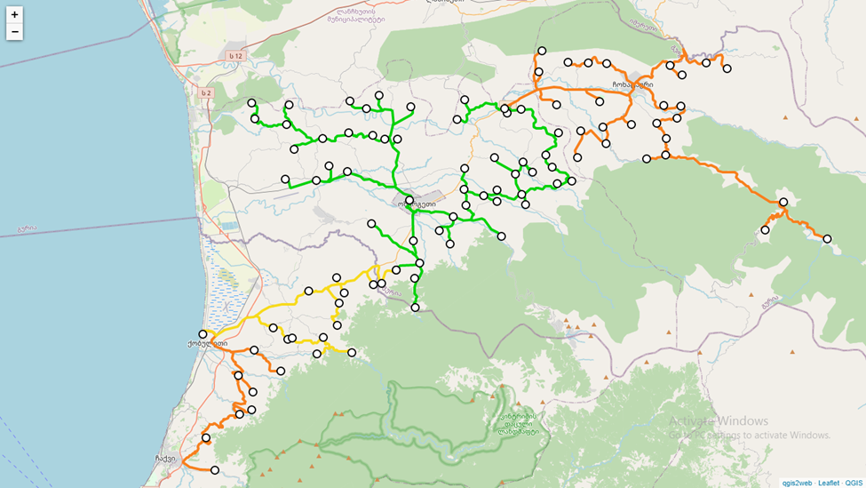

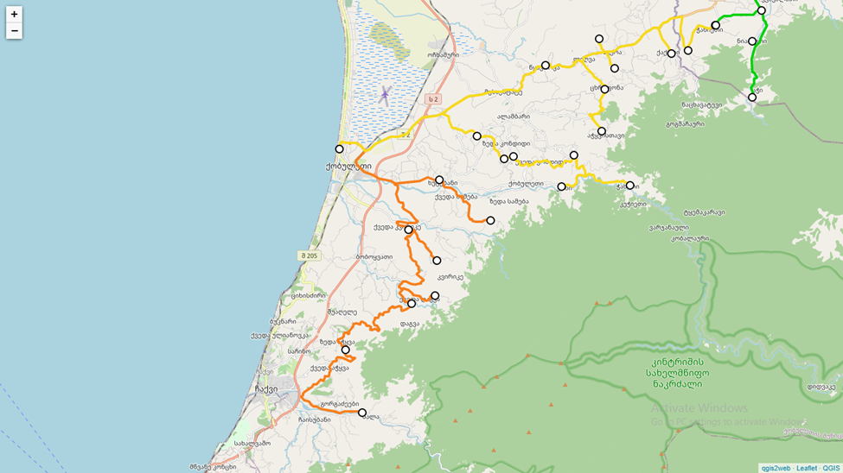

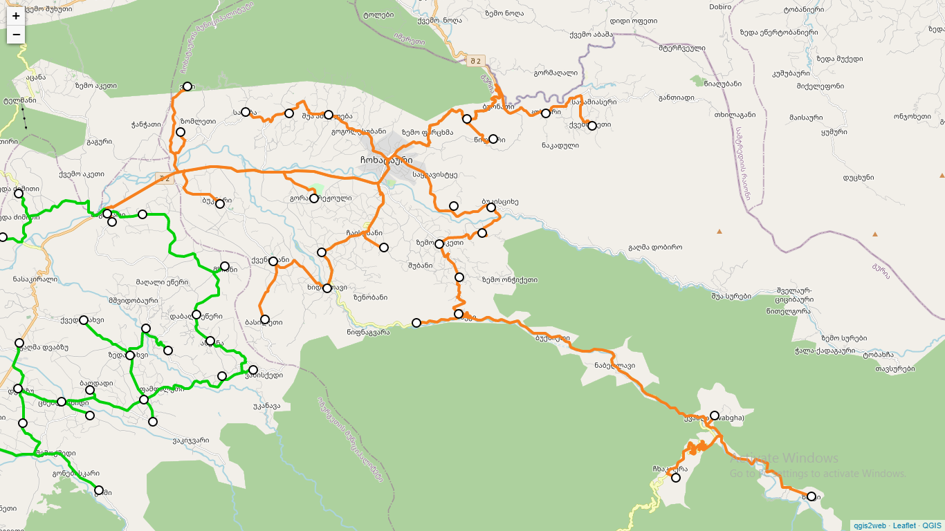

**Legend of Maps:**

**Green line -** Completed pilot project in Ozurgeti Municipality funded by Government of Georgia;

**Yellow line -** Upcoming works in Kobuleti Municipality funded by Government of Georgia;

**Orange Line -** Planned works in Kobuleti, Chokhatari and Racha-Lechkhumi-Kvemo

Svaneti regions funded by World Bank and Government of Georgia

**Photos**

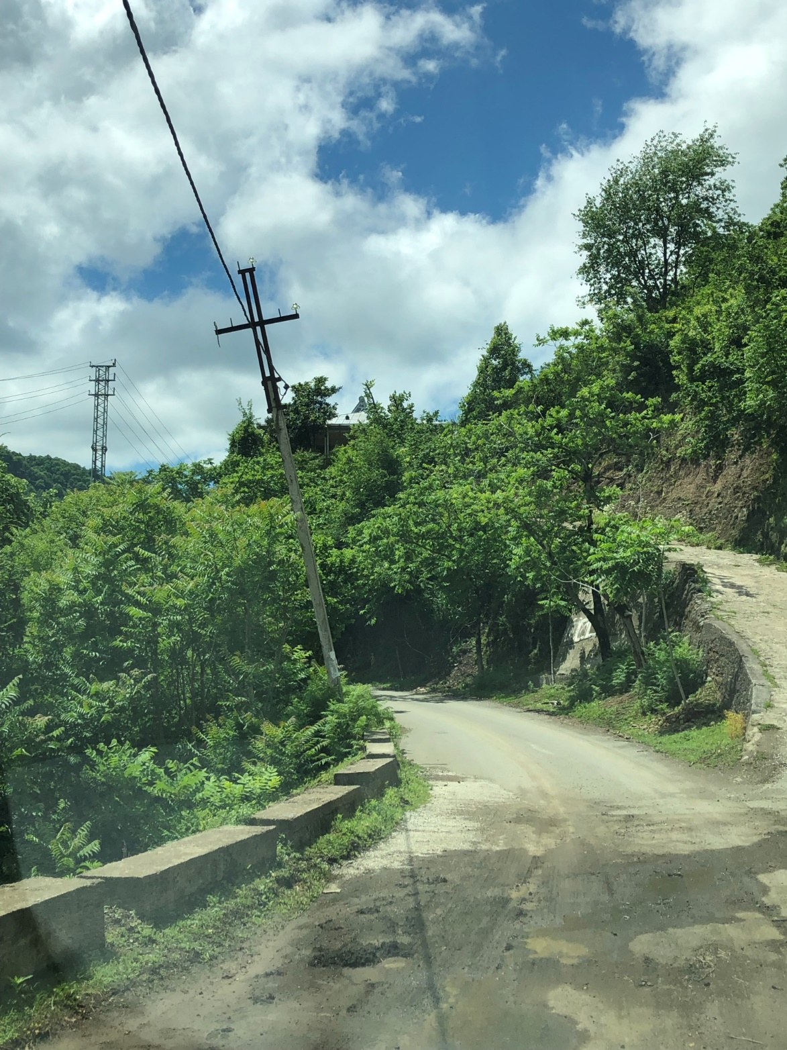

Pic. 1 Proposed route near village Khutsubani, Kobuleti municipality.

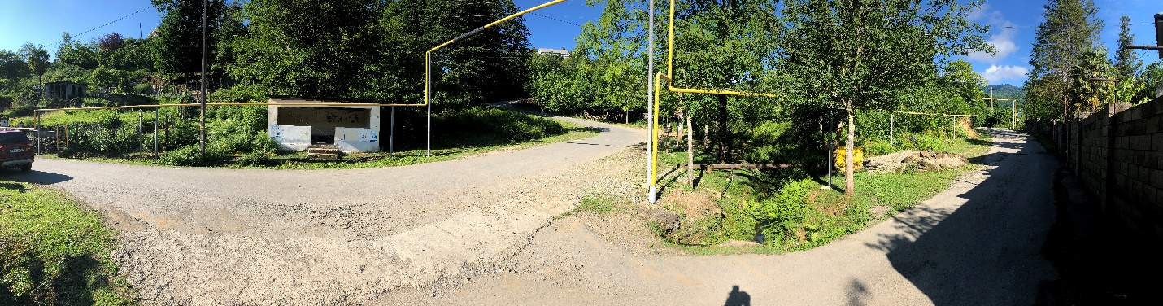

Pic. 2 Proposed route near village Leghva, Kobuleti municipality.

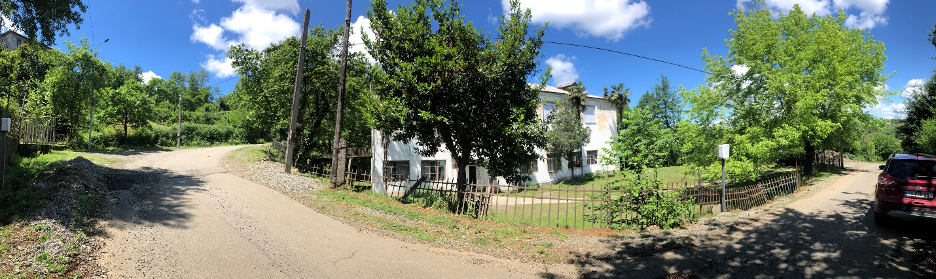

Pic. 3 Proposed route near village Khutsubani, Kobuleti municipality.

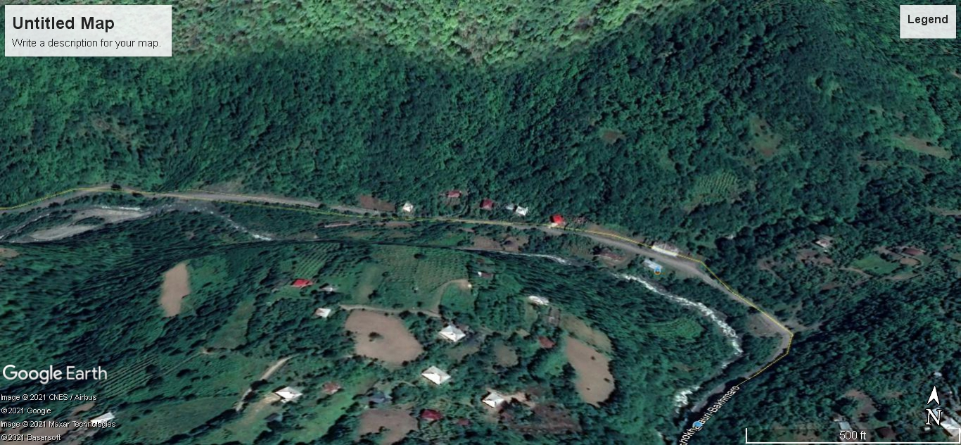

Pic. 4 Proposed route near village Nabeghlavi, Chokhatauri municipality, (Source-Google Earth Pro).

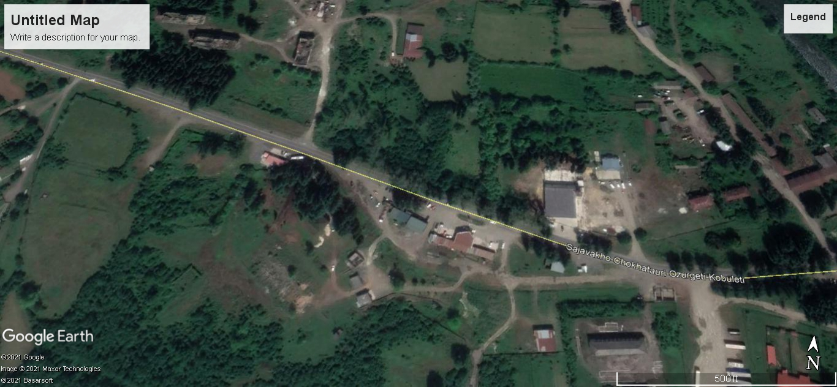

Pic. 5 Proposed route near village Chokhatauri, Chokhatauri municipality, (Source-Google Earth Pro).

**Attachment 2**

**Occupational Health and Safety Plan**

1. **Purpose of Occupational Health and Safety Plan**

This occupational health and safety plan has been developed to provide mitigation measures against potential health and safety risk identified in Environmental and Social Management Framework (ESMF) and Labor Management Procedure (LMP) and also provides guidance on integration of health and safety issues in implementation of Log In Georgia Project. The document applies to construction contractors and sub-contractors that are involved in the project activities and address the issues that may impact the health and safety of workers, local community and general public.

The plan describes construction related hazards and risks, provides detailed instructions to construction companies in managing critical areas of occupational health and safety, provides a general description of the levels of personal protection and safe operating guidelines expected of workers and establishes personnel protection safety practices and procedures.

Additionally, the document assigns responsibilities and addresses the issues of monitoring and reporting requirements.

1. **Duties and Responsibilities of Involved Parties**

Occupational health and safety management related duties of involved parties are provided below:

***Open Net:***

* Oversee overall compliance of project activities with requirements of World Bank Environmental and Social standards, Project health and safety requirements (ESMF, LMP), and national legislation;
* Ensure that H&S requirements are included in the contracts for construction contractor;
* Conduct periodic site visits;
* Review relevant reports from the construction contractors and/or supervision consultants;
* Regularly communicate reporting and incident related observations to World Bank;
* Ensure that appropriate health and safety personnel is hired by construction contractor and supervision consultant;
* Review and approve H&S management plan, Code of Conduct, labor management procedure, traffic management plan, community health and safety plan and other documents developed by construction contractor;
* Ensure that training and orientation is provided to the personnel of construction contractor;

***Supervision Consultant/Technical Supervisor:***

* Be aware of any risks, hazards or emergencies that may occur during the construction activities:
* Hire respective Health and safety specialist;
* Review and approve construction contractor’s CESMPs, including H&S Plan, community health and safety plan, H&S training materials (including SEA/SH issues), COVUD-19 emergency action plan and other relevant H&S documentation;
* Carry out regular supervision of construction works on to ensure that construction contractor follows the health and safety requirements specified in the contract and respective H&S documentation;
* Record and communicate identified health and safety deficiencies construction contractor, recommend corrective measures and establish timeline for implementation of corrective actions;
* Participate in investigation of incident, review information, carry out inspection visit, communicate incident related details to Open Net;
* Respond to complaints regarding construction contractor’s activities that may impact the safety of employees, visitors and local community or that represent an immediate danger;
* Issue instruction to construction contractor to stop activities in case an immediate danger is observed (stop work). Work shall be resumed only when appropriate corrective actions are implemented by construction contractor. The results of corrective actions shall be approved and documented supervision consultant;

***Construction Contractor:***

* Comply with the health and safety requirements specified in the contract, CESMP, national legislation, ESMF, and LMP.
* Develop H&S training materials and ensure that appropriate training and orientation is provided to all workers;
* Hire health and safety specialist and conduct regular site safety inspections at construction sites;
* Develop and periodically update all necessary Health & Safety documentation, including H&S Plan, community health and safety plan, traffic management H&S training materials, and other relevant plans and procedures; Ensure that all the documents are agreed with Supervision Consultant; (detailed list of the documents to be developed by construction contractor is provided in Annex 1.);
* Be responsible for coordinating activities with all the sub-contractors on construction site;
* Ensure that all workers attend H&S training and orientation and are well aware of project H&S requirements prior to commencement of construction activities;
* Ensure provision of respective personal protective equipment (PPE) for all workers;
* Provide safety signs and warning notices at construction sites;
* In the event of an incident and/or accident ensure that appropriate procedures are followed, respective documentation is developed and timely submitted to supervision consultant and other relevant parties;
* Develop monthly reports and submit to supervision consultant in a timely manner.

1. **Preconstruction Planning and Risk Assessment**

The following section provides information on pre-construction activities recommended for construction contractor in identifying and assessment of the general, chemical, physical hazards that may occur during construction activities. Pre-construction planning for the construction contractor includes but is not limited to the following activities and shall be carried out before the commencement of construction works:

* Assess Health & Safety risks related to construction activities;
* Develop health & safety plan, community health and safety plan, and other respective H&S documentation;
* Develop H&S training materials, and provide training and orientation to workers before construction activities start;
* Define safe working procedures and ensure availability of relevant personal protective equipment;
* Ensure that Material Safety Data Sheets (MSDSs) are available for the materials to be used during the construction process;
* Develop traffic management plan and labor management procedure, establish emergency procedures, and provide appropriate training to workers;
* Hire H&S specialist and make sure that construction activities are regularly monitored and respective records are being developed;

***Assessment of Risk and Hazard Analysis***

Construction contractor has to ensure a safe work site for workers, visitors and the local communities by ensuring that appropriate procedures are in place for dealing with identified hazards in a timely and effective manner.

During the risk assessment process Construction Company should also take into consideration how construction works are organized, the condition of each construction site or section of route, information and training needed by workers and the types of control measures available.

Based on the preliminary risk assessment workers will be exposed to the following potential occupational health and safety hazards, primarily including but not limited to:

Working near Heavy Equipment and machinery

Personnel working in the immediate vicinity of heavy equipment (loaders, excavators, trucks, etc.) may encounter physical hazards. Workers should take appropriate action to avoid them at all times. Workers must be careful to communicate with heavy equipment operators regarding their location, and shall maintain a safe distance from operating equipment at all times. Prior to working around equipment, the site personnel shall review appropriate hand signals with the operator. All construction technique should be equipped with back up alarms.

Trenching and excavation

Potential health and safety hazards include falls into tranches and excavations, excavated materials and other objects falling on the workers, unstable slopes of the trenches, incidents involving equipment. The workers involved in the trenching activities should follow the basic rules of health and safety, they should never enter the deep tranches unless the slopes are stable and properly sloped, never work alone in a trench.

Traffic

Based on the design project, significant amount of construction activities will take place on the municipal roads in populated areas/settlements so vehicular and pedestrian traffic is expected. Appropriate precautions to protect the workers and civilians shall be used including special road construction signs, also special persons can be designated to help traffic control in the areas of heavy traffic. To control traffic related risk construction contractor should develop separate traffic management plan.

Slips, Trips, and Falls

Working in the construction site may pose slip, trip and fall hazards due to equipment, piping, slippery surfaces that may be oil covered, or from surfaces that are wet from rain or ice. Potential adverse health effects include falling to the ground and becoming injured or twisting an ankle. Good housekeeping at the site must be maintained at all times.

Hand and Power Tools

The use of hand and power tools can present a variety of hazards, including physical harm from being struck by flying objects, being cut or struck by the tool, or electrocution. Workers shall wear proper personal protective equipment, including eye protection, while utilizing hand and/or power tools. The tools should be checked for any damage before each use.

Fire and Explosion

Prior to starting excavation works, construction contractor should review appropriate maps to identify underground utility and gas lines or pipelines to minimize possibility of encountering, fire and explosion hazards. The fire and explosion can also occur from using flammable construction materials and fuels. All flammable substances should be located in an appropriate places and under strict control to minimize the risk of fire and/or explosion;

Material Handling/lifting operations

Manual lifting of heavy objects may be required at the construction sites. Failure to follow proper lifting techniques can result in body (back, spine) injuries and strains. Back injuries are a serious concern as they are the most common workplace injury, often resulting in lost or restricted work time, and long treatment and recovery periods. Whenever possible, heavy objects must be lifted and moved by mechanical devices; Objects that require special handling will only be moved under the guidance of a person who has been specifically trained to move such objects.

Utilities

Prior to the start of any intrusive works/excavation activities, the location of above-ground and underground utilities should be identified by the construction contractor responsible for completing construction activities, in order to avoid possibility of encountering fire and explosion hazards exists from under-ground utilities and/or gas lines (see fire and explosion passage above).

Hazardous Materials

Asbestos (asbestos containing materials- ACM), may be encountered during the construction works mostly in the form of pipes (water disposal and other). Effects on the lung are a major health concern from asbestos, as long-term exposure to asbestos in humans via inhalation can result in a serious lung disease. Detailed guidance and requirements for hazardous material management are provided in Waste Management Plan.

Biological Hazards

During the course of the construction activities, there is a potential for workers to come into contact with biological hazards such as animals and insects. During site operations, animals such as street dogs, cats, snakes, rodents, spiders, wasps etc., may be encountered. Workers shall use discretion and avoid all contact with animals and insect. The workers are also under the risk of exposure to pathogenic hazards coming from unsanitary sites.

Extreme temperatures

Working in high temperatures and heat stress is a significant potential hazard, which is greatly exacerbated with the use of PPE, in hot weather conditions. The potential hazards of working in hot environments include dehydration, cramps, heat rash, heat exhaustion, and heat stroke. If onsite workers exhibit the signs of heat exhaustion or heat stroke, they shall seek immediate medical attention.

Workers may be exposed to the hazard of working in a cold weather conditions as well. Potential hazards include frostbite, immersion foot, hypothermia, as well as slippery surfaces, and poor judgment. The workers are responsible for dressing warmly in layers with thick socks, gloves, and appropriate head and face gear. Upon the onset of discomfort due to the cold, onsite workers shall take regular short breaks to warm up inside buildings and to drink warm fluids. All contractors and employees shall identify a place to warm up in advance. If discomfort continues and the workers start to exhibit the signs of frostbite, hypothermia, they shall seek immediate medical attention.

Noise

Noise is a potential hazard associated with the operation of heavy equipment, power tools, pumps and generators. Hearing protection is required and shall be used in designated areas of the site as indicated by the posted signs. Contractors employing construction equipment such excavators, jackhammers, are required use mitigation measures which may include mufflers, etc. Construction activities will occur during hours that minimize noise disturbance to the community.

COVID-19 infection

COVID-19 infection outbreak may cause spread of disease among personnel of construction contractor and its transmission to the communities in the settlements located close to the construction sites. Also, worsening of epidemiologic situation nationwide or in particular regions of the country may lead to imposing of radical restrictive measures, including suspension of construction activities.

***Requirements and precaution measure for pre-construction stage***

The following general precaution measures are recommended for consideration during pre-construction planning and site mobilization phase to be carried out by the construction contractor:

* The construction site should be clearly demarcated, warning signs should be installed as needed to avoid unauthorized entry;
* Install suitable direction, speed limit and priority signs, as needed; appropriate signs should be installed at traffic routes, material and waste storage / accumulation areas as well;
* Provide and ensure that all workers on site and authorized visitors are using Personal Protective Equipment (PPE);
* Ensure that routes for heavy machinery, vehicles and workers are marked, well maintained and in a safe condition;
* Ensure that vehicle and heavy machinery drivers are suitably trained or licensed;
* Ensure that existing electricity, gas and other utility lines (buried or overhead) are identified; Necessary precaution measures should be taken to ensure that power lines and electrical systems are in a safe condition;
* Ensure that first aid facilities are available at all constructions sites and workers and other project personnel are inform about the locations of the first aid stations.
* Ensure that fuel and other flammable liquids are stored in approved storage area with impermeable floors to avoid any leakage in case of spill;
* Ensure adequate supply of water;
* Ensure adequate number and location of sanitary and washing facilities and their regular maintenance;
* Ensure adequate number of location of change, rest and eating facilities for workers;
* Provide adequate places for storing worker’s clothes and PPE; such facilities should be easily accessible and should also ensure privacy of the user.
* Restrict naked flames;

***Training and Orientation***

All workers and employees of construction contractor and any involved sub-contractor (including temporary local workforce) should obtain training and orientation on health and safety issues. The training sessions should be provided by technical supervisor’s H&S specialist and construction contractor’s H&S specialist. The training materials should be approved by technical supervisor.

Training materials shall include but not be limited with the following topics: risk and hazard assessment, health and safety awareness, general safety measures for construction works, proper use of personal protective equipment (PPE), handling of hazardous and non-hazardous waste, handling of incidents, sexual exploitation and abuse and sexual harassment and HIV/ aids (SEA/SH) issues, H&S monitoring, communication and reporting, etc. Training attendance registers shall be maintained by H&S specialist of construction contractor and shall be made available to technical supervisor and Open Net upon request. Open Net should be informed on training sessions and allowed to attend them, as needed.

All new workers hired after the commencement of construction works should receive training and orientation as well. Tool box talks should be conducted at the job site regularly, prior to the commencement of trenching, cable laying, or backfilling activities, covering special topics of the specific works related to associated risks and hazards as well as safe work practices to be performed in the period.

In case frequent violation of project health and safety requirements the supervision consultant should conduct additional training sessions throughout the implementation phase of construction activities for workers, management and health and safety specialist of the construction contractor.

1. **Health and Safety Risk Control**

To protect workers and other potentially exposed personnel all safety rules given in the project H&S documentation must be obeyed by construction contractor and the following procedures and protocols should be adopted and used as needed:

Construction sites

Construction contractor is responsible for providing a safe place of work, and maintaining safe access to the work sites. Access routes, whenever practicable, should permit workers to pass along without bumping into obstructions or construction debris. While conducting the excavation activities, access to and from construction site should be along well-defined routes. Construction contractor should undertake the following steps:

* Where possible, the route used by trucks should be separated from that used by the workers. Where this is not practicable the movement of workers should be prohibited while truck are being operated and vice versa;
* Loose stones, gravel and large rocks should be removed from the routes used by workers or heavy trucks.
* Accumulations of mud should be prevented and sloping walkways should be cleared or otherwise made slip-proof;
* The contractor shall provide a suitable hygiene facility to allow the workforce to change from regular cloths to work cloths and back at the beginning and end of each working day. This shall include adequate washing facilities as well;
* Smoking, drinking, and eating shall be strictly prohibited in the work areas;
* Contractor must ensure that there are basic medical facilities on site and that there are staff members trained in the delivery of first aid.
* Appropriate posting of information within the site must be done to inform workers of key rules and regulations to follow.

Personal Protective Equipment (PPE)

All workers and employees (including temporary local workforce) or any person at the construction site shall be provided with and use appropriate personal protective equipment (PPE). The use of PPE is to combat exposure to hazards when engineering and/or administrative controls are not feasible or effective in reducing these exposures to acceptable levels. Workers must wear the following basic protective equipment:

-Safety helmets all times at the construction site;

-High quality slip-resistant safety boots all time at the construction site; Safety boots should be to prevent slipping; toe-cap is also required to prevent crushed toes when working with heavy equipment or falling objects;

-Gloves made of suitable material;

-Eye and face protectors for particular type of hazards. Workers must wear safety glasses, goggles or face shields while cutting (asphalt, concrete), pneumatic nailing, or when working with harmful and dusty materials;

The PPE worn during handling of hazardous waste and materials shall be prohibited for re-use during other construction activities.

Safe Excavations

Construction contractor should appoint trained and experience workers at each excavation site. To prevent health risks or any other emergencies the following precautionary measures should be considered:

* Contact the local utility companies to identify the location of all underground utilities (gas, electricity lines) before the commencement of excavation activities;
* Workers should be kept away from digging equipment, from space between equipment in use and other obstacles and machinery; never allow workers to access the excavation area when machinery is in use;
* Construction contractors H&S specialist should conduct regular inspections on excavation activities to prevent any hazards before workers enter a trench or excavation;
* Workers should be provided with a way to get into and out of a trench or excavation such as ladders as needed;
* Keep drivers in the cab and workers away from trucks when debris or wastes are being loaded into the machinery;
* Ensure that appropriate signage is displayed at excavation sites;

Confined Space

Confined space is an area which is enclosed with limited access which makes it dangerous. Confined spaces at construction site may include manholes, wells, underground pipes, or other type of enclosure. Employees may enter in confined space during installation works of optic fiber cable. Hazards in a confined space often include suffocation or electrocution (depending on the function of a confine space). General safety measures for works in confined consists of the following procedures:

* Provide all equipment necessary to ensure the safety and health of workers;
* Confine space should be tested to ensure the absence of any hazardous gas and no deficiency of oxygen; Clean and ventilate the confined space to ensure that it is a safe work site;
* All power source to mechanical equipment should be disconnected which may cause danger inside a confined space;
* working in confined spaces requires at least one person who remains outside of the confined space and is in constant contact with workers entering the confined space;
* Provide all confined space workers with instructions and ensure that they are wearing relevant PPE; if the use of spatial breathing equipment is required, ensure that the person is also wearing a safety harness connected to a lifeline, the free end of the lifeline is held by a person who is capable of pulling him out of the confined space in case of emergency;

Portable power tools

Construction company’s employees working with portable tools should obey the following general safety rules for portable power tools:

* Portable tools should be properly maintained and kept in a safe place according to the manufacturer’s instructions;
* Regularly check equipment for defects before use;
* Never overload the manufacturer’s specifications and recommendations;
* Do not use broken or damaged plugs, sockets and switches,
* Do not modify any equipment;
* Switch off supply immediately after work;
* Do not expose electric power tools to rain or wet conditions; wet tools increase the likelihood of electric shock;
* Workers using powder-activated tools must receive proper training prior to their use and use proper PPE;

Lifting operations

Lifting devices, including equipment, slings, ropes, chains, and straps, will be checked before use, to confirm their weight capacities. Defective equipment will be taken out of service immediately and repaired. Personnel will not pass under a raised load, nor will a suspended load be left unattended. All material must be stored in tiers, racked, blocked, or otherwise secure to prevent sliding, falling, or collapse. All loads/material will be verified to be secure before transportation.

While conducting lifting works workers should:

* Do not lift or handle more than easily can be managed;
* Remove obstructions from the place;
* Adopt stable position and keep load close to waste;
* Never bend the back when lifting, avoid twisting the back or leaning sideways;
* Move smoothly, put the load down first and then adjust;

Working with fiber optic cable

Exposure to the glass fibers and optical radiation to the eyes and skin are major health hazard associated with optic fiber cable installation works. Small cuts of fibers are be very dangerous to eyes and lungs, and can cause serious injuries to these organs.

Workers should avoid stripping or cutting of cables and use safety googles/safety glasses with side shields, masks, gloves and other appropriate PPE. Direct contact with the cable with bare hands should be avoided. Touching the face while working, should be avoided as well, since the splinters from fiber can easily penetrate the skin and cause itching or bleeding, and they are very difficult to remove.

Data signals transmitted through the light which is invisible to naked human eye. Workers should not directly look into the cables since invisible light can cause burn of retina and sever damage of eyes or loss of vision.

Noise control

Construction workers are likely exposed to noise which mostly generated by construction equipment. The following safety measures are to be conducted by construction contractor to minimize noise impact on employees:

* The workers should wear hearing protection as needed;
* All power tools and construction equipment should be properly maintained;
* Compressors, generators, and other types of equipment which are sources of noise should be located as far away from the working site as possible;
* Rest breaks at suitable intervals should be arranged for workers exposed to noise;
* Noise level should be measured on a regular basis and conduct remediation measures as needed;

Handling Spills

During refilling activities of the construction machinery or temporary storage of fuel spill can occur. Any spills or releases fuels, oils, lubricants or other chemicals shall be immediately responded. Appropriate reporting should be submitted to supervision consultant. In case of significant spill relevant report shall be submitted to Open Net as well. It is construction contractor’s responsibility to cover all spill clean-up related costs.

In case of spillage the construction contractor absorb spilled material with sand, earth, saw dust or other special absorbents, spilled material should not be allowed to enter drains and water bodies, contaminated soil should be stripped, all contaminated adsorbents, sand, soil and PPE should be treated as a hazardous waste and should be disposed in an approved disposal site;

After completion of cleanup, the proper documentation providing information on spills, the causes, damage to natural or social environment (if any), amount of hazardous waste, disposal methods and undertaken remediation shall be provided to the supervision consultant.

Safety of general public and pedestrians

Contraction contractor is responsible to ensure that local community members passing nearby the construction sites are not injured by the heavy machinery or other construction equipment. In order to reduce the risk of any accident the contractor should ensure that all construction sites are fenced in the settlements and appropriate signs are installed to prevent unauthorized access by public/pedestrians; ensure that access is controlled to all construction sites both during and after work hours; construction works should be planned in such a way to ensure that the minimum number of trenches is left open after hours or during weekends.

Contraction contractor also has to have procedures of informing visitors and other persons entering the site about hazards on site and providing appropriate PPE. Construction contractor shall also maintain a visitor’s register as well. Contractor should restrict working at night in settlements;

Construction contractor should also conduct dust control measures along the route of cable. Water should be applied regularly on the affected areas, along the trenches, depending on the atmospheric conditions. Special coverage (e.g. polymer) can be applied to protect excavated soil from wind or water erosion as needed.

More details on safety of general public and pedestrians and respective remediation measures will be provided in Traffic Management Procedures and Community Health and Safety Plan (see list of documents to be developed by construction contractor in Annex 5).

Biological hazards

During the construction works workers are likely to expose to different life threatening pathogens; insects, reptiles, street dogs, cats and rodents may also be encountered. Bites and scratches from animals can be painful and the potential for contacting rabies exists.

To lower the risks from biological hazards: The employees of contraction contractor shall avoid all contact with animals, use biocides and/or other disinfectants to reduce the risk of infection; exercise due caution, use appropriate PPE and follow appropriate hygiene procedures when local sewerage systems is encountered.

Alcohol and drug abuse

To lower the risks of hazards associated with alcohol consumption and illegal substance abuse contraction contractor should prohibit use of alcohol or illegal substances at construction sites, provide appropriate information and awareness to workers, check workers before each working day to ensure that they are not under the influence of alcohol or illegal drugs;

Covid-19

Open Net will keep works contractors informed on the current guidance of the World Health Organization and regulations of the Government of Georgia in force regarding control of COVID-19 infection spread. Construction is required to strictly follow these regulations. Information on the infection control measures should be posted in visible locations at each construction sites and respective amount of sanitizers and face masks should be provided.

Contractor company also will be required to develop and agree with the supervision company and the Employer (Open Net) emergency action plan to address outbreak of disease among personnel. (ESMF)

The above section covered all major health risk and hazard which may be encountered during the construction phase. However, if other labor risks arise during project implementation, Open Net will develop procedures to prevent further impacts and the site specific plans developed by contactor contractor will be updated accordingly.

1. **Handling of incidents**

Construction contractor should immediately inform the technical supervisor on any incident that occurs at a construction site. Incident report shall be developed and submitted by the H&S specialist of the contractor to the technical supervisor with a copy to Open Net within 24 hours in case of any event given below:

* Significant damage to public utility lines (water pipes, gas pipes, underground electricity cables);
* Explosion or fire that causes significant damage at construction site, or prevents the continuation of regular works;
* Overturning or collision of heavy machinery;
* Spill or release of significant amount of hazardous materials;
* collapse of trench or slope;

In case of incidents involving death, or serious injury, or incapacity of construction worker, or involving a member of the public or local community, construction contractor’s H&S specialist shall immediately inform the technical supervisor and submit incident report. The incident report shall include details on location of incident, individual involved, information on damage/ caused, corrective actions, as well as other relevant information, supported by photographs.

In addition, construction contractor shall develop final report of incident investigation no later than two weeks after incident. All incidents should be investigated by the competent professional (relevant independent professionals can also be involved, as needed). Final report on incident investigation shall include information on objectives of investigation, causes of incident, methodology applied, analysis and tests carried out, findings, conclusions and recommendations, to avoid the risk of the similar types of incident occurring in the future.

1. **Monitoring and Reporting**

Construction contractor H&S specialist shall develop and submit to the technical supervisor weekly reports. Supporting materials, such as copies of H&S documents, photos, field visit checklists, materials developed during the reporting period should be attached to progress report.

Site inspections will be carried out by technical supervisor as well. Supervisor shall review and approve the occupational H&S Plan, community health and safety plan, labor management procedure, training materials, and other relevant health and safety documents developed by construction contractor. Technical supervisor approves them prior to commencement of construction activities. Following request from Open Net, supervisor shall communicate H&S documents to ensure their agreement prior to provision of its approval. Technical supervisor shall develop and implement H&S monitoring system as well.

During the course of construction works supervisor shall communicate with contractor on a regular basis and provide with observations on H&S issues. The following measure shall be undertaken by technical supervisor:

* Shall agree on corrective actions and implementation timeline in case any deficiency or incompliance with H&S requirements is observed at any construction site;
* Shall review all incident related documents (including incident report, final report on incident investigation). Contractor shall ensure that information is presented correctly and provided timely and provide recommendations for corrective actions and timeline if necessary;
* Shall review construction contractor progress report to ensure that the document represents adequate information on H&S issues;

Technical supervisor shall develop and submit to Open Net reports (the frequency of reporting will be provided in the respective contract with supervisor). Progress report should include at least the following: Information on site inspection activities, summary of findings of inspections and details on any H&S deficiencies or incompliance, any incidents and/or emergencies observed at any construction site; conclusions of reviewing progress reports submitted by construction contractor with respect to compliance to H&S requirements.

Open Net will also carry out periodical site inspections, monitoring and review of documents/reports.

**Attachment 3**

**Waste Management plan**

**1. Purpose of waste management plan**

This Waste Management Plan (WMP) is a part of the Environmental and Social Management Plan (ESMP) and has been prepared for Log in Georgia Project to define waste management related responsibilities of all involved parties. The document provides practical guidance prepared for use by the construction contractor as well as will serve as a reference for technical supervisor company (if hired), and Open net during supervision and monitoring of waste management requirements during implementation of construction works.

WMP applies to construction companies’ activities that are associated with generation, handling, storage, transportation and final disposal of waste and defines procedures that shall be followed by construction contractor to minimize the impact on environment.

This plan will also ensure that all hazardous materials that can be encountered or generated during the construction phase are managed, stored, transported and disposed according to the World Bank standards, requirements of national legislation and good international practices. WMP addresses duties and responsibilities, training requirements, personal protective equipment, risk management, transportation and disposal of waste.

**2. Objectives of waste management plan**

The main objectives of Waste Management plan are as follows:

* Identify the roles and responsibilities of involved parties during the construction phase;
* Provide overall guidance for handling non-hazardous and hazardous waste generated during the trenching, cable laying and backfilling works;
* Reduce the potential for release of potentially hazardous materials to the ambient air, soil and water bodies;
* Protect the health of the workers, site users and general public; identify the required personal protective equipment (PPE) to be worn during the construction activities.
* Identify procedures that need to be followed on the removal, handling, temporary storage, transportation and final disposal of the hazardous and non-hazardous waste.

**3. Duties of involved parties**

***Open Net***

* Oversee overall compliance of program activities with environmental and social, requirements of the World Bank/Environmental and Social Framework/Environmental and Social Standards (ESS);
* Develop WMP (as part of ESMP) to address potential waste management issues, and recommend appropriate procedures and measures to ensure proper handling, storage, transportation and final disposal of waste (including specific procedures for hazardous waste);
* Ensure that waste management related clauses and requirements are included in the contracts for construction contractor and technical supervisor;
* Review and approve the waste management plan of construction company and any future updates.
* Communicate reporting of waste management issues to the World Bank, as needed/or on the regular basis.
* Ensure that training and orientation provided to the personnel of construction contractor cover waste management issues;
* Review of periodic reporting submitted by construction contractor and supervision company (including sections related to waste management);
* Carry out periodic site visits with monitoring purpose;
* provide regular reports to the WB including waste management issues;

***Technical supervisor***

* Be knowledgeable concerning waste management issues that may occur during construction works;
* Ensure that the hazards related to works with hazardous waste present at site are duly reflected in the Construction Contractor’s H&S plan;
* Carry out regular supervision of construction works to ensure that Construction Contractor follows the waste management requirements specified in this WMP, the contract, ESMP, as well as requirements of national legislation and WB standards.
* Communicate waste management related deficiencies to construction contractor, recommend corrective measures (as needed), establish timeline for implementation of corrective measures;
* Ensure that all hazardous and non-hazardous waste is safely handled and disposed in agreed locations. Ensure that appropriate documentation and reporting is developed and available;
* Develop specific training materials on handling, storage, transportation and disposal of hazardous materials and waste and ensure that contractor’s environmental and H&S specialist provide appropriate training and instruction to all workers dealing with hazardous wastes.

***Construction Contractor****:*

* Be familiar with and comply with the contents of this Waste Management Plan;
* Develop training materials, provide training and instruction to workers for addressing waste related issues (including hazardous waste) in compliance with procedures specified in environmental and social documents developed for the project, including this WMP;
* Ensure that all waste related procedures and documents are in place and agreed with technical supervisor;
* Ensure provision appropriate PPE to all workers dealing with waste, and special proper PPE and equipment to workers dealing with hazardous materials and waste;
* Employ qualified environmental and H&S specialist to guide and instruct waste related activities;
* Conduct regular site inspections at work sites;
* Maintain waste management log to record types, amounts and activities carried out with respect to wastes;
* Manage reports development and timely submission.

In case of sub-contractors involvement, it is construction contractor’s responsibility to ensure that waste management related training are provided to their personnel prior to commencement of construction works. The construction contractor shall ensure that the sub-contractor is actually implementing the waste management related requirements of this WMP.

**4. Waste management procedures**

***General approaches for Waste Management***

One of the priorities throughout the planning, implementation and operation of the project is to avoid potential negative environmental and social impact. However, certain impacts remain likely to occur or are unavoidable, and for these, respective mitigation measures have been developed to minimise the likelihood, severity, extent or duration of occurrence, and any associated adverse effects.

The proposed waste management related measures have been consolidate in the following part of the document. This section of the waste management plan presents proposed mechanism for waste management to ensure that waste is managed appropriately in order to ensure maximization of re-use and recycling and overall waste minimization as well.

Construction contractor shall follow the procedures provided in this section and is required to ensure the minimization of waste generation wherever possible. Overall residual waste materials which can’t be avoided fall into the following categories:

* Re-use for the project purposes;
* Recycle / recovery;
* Safe disposal on site (for non-hazardous materials, );
* Disposal on the landfill according to the project requirements.

To achieve waste prevention and minimization the following measures are recommended:

* Re-using materials on site (for example excavated soil).
* Instituting good housekeeping and operating practices, including inventory control to reduce the amount of waste resulting from materials that are out-of-date, off-specification, contaminated, damaged, or excess to site needs;
* Substituting raw materials or inputs with non- or less hazardous or toxic materials wherever economically and technically feasible;
* Arrange and control areas for waste temporary accumulation on site;
* Timely collect the waste generated during works and accumulate at designated places of work site;
* Arrange timely collection, transportation and disposal of generated waste at landfills or other approved locations.
* Storage of hazardous waste sites shall be located on an impermeable surface, to ensure that no leakage, spillage or damage has occurred and that all containers/boxes/bags containing hazardous materials are being labelled and stored.

The construction contractor is required to collect, segregate, temporarily store and finally dispose of each type of waste stream in accordance with the general guidance provided in the table below:

| **Type of waste** | **Source of waste** | **Hazard** | **Temporary storage** | **Final disposal** |
| --- | --- | --- | --- | --- |
| Excavated soil | From trenching activities | Non-hazardous | No storage; excavated soil will be re-used on site for backfilling; | On site |
| Excavated asphalt layer | From trenching activities; | Non-hazardous | Segregated and stored in an approved waste accumulation area on site; | Can be collected for crushing and re-use for backfilling;  Potential uses include paving of access roads as well; |
| Concrete | Concrete debris generated during demolition works of municipal road paving; | Non-hazardous | Segregated and stored in an approved waste accumulation area on site; | Can be collected by construction contractor for crushing and re-use;  potential uses include establishment of access roads and as aggregate; |
| Iron and steel scrap | Associated with formwork (if used) and reinforcement activities, and generated during equipment repair; | Non-hazardous | Stored in an approved waste accumulation area on site; | Collected by construction contractor and handed over for recycling; |
| Non-ferrous metal | Associated with formwork (if used) and reinforcement activities, and generated during equipment repair; | Non-hazardous | Segregated and stored in an approved waste accumulation area on site; | Collected by construction contractor and handed over for recycling; |
| Packaging | Associated with material deliveries; | Non-hazardous | Segregated and stored in an approved waste accumulation area on site; | Collected by construction contractor and handed over for recycling; |
| General household Solid Waste (domestic waste, including food waste) | Construction camps (if used), worker’s welfare and sanitation facilities; | Non-hazardous | Segregated and stored in an approved waste accumulation area on site; | Collected by construction contractor and handed over for recycling (if possible) or final disposal at an approved area/municipal landfill. |
| Glass | Worker’s welfare and sanitation facilities; | Non-hazardous | Segregated and stored in an approved waste accumulation area on site; | Collected by construction contractor and handed over for recycling (if possible) or final disposal at a municipal landfill. |
| Plastics | Construction camps (if used), worker’s welfare and sanitation facilities. Associated with material packaging as well. | Non-hazardous | Segregated and stored in an approved waste accumulation area on site; | Collected by construction contractor and handed over for recycling (if possible) or final disposal at a municipal landfill. |
| Paper and cardboard | Construction camps (if used), worker’s welfare and sanitation facilities; Material packaging; | Non-hazardous | Segregated and stored in an approved waste accumulation area on site; | Collected by construction contractor and handed over for recycling (if possible) or final disposal at a municipal landfill. |
| Timber | Associated with trenching works, if tree cutting and removal is needed. | Non-hazardous | Stored on an approved accumulation area on site; | Collected by construction contractor and handed over to municipal authorities/or regional services of National Forestry Agency; Or trees cut by the construction contractor made available to PAPs for timber (RPF). |
| Tyres | Machinery maintenance and repairs | Non-hazardous | Stored on an approved accumulation area on site; | Collected by construction contractor and handed over for recycling; |
| Oils and lubricants | Machinery and equipment maintenance and repair | Hazardous | Collected in a safely manner and store in specially designated hazardous waste accumulation area; | Collected by construction contractor and handed over to competent organization for recovery and re-use/ or for final disposal. The other options can be incineration or hand over to cement plants. |
| Asbestos containing materials | Generated during relocation of the existing infrastructure (asbestos-containing pipes). | Hazardous | Safely stored in specially designated hazardous waste accumulation area on site; | Collected by construction contractor (by trained workers using PPE) and to be disposed in an approved landfill. Procedures on removal, handling, temporary storage and final disposal of asbestos is provided below in this document. |
| fiber optic cable (FOC)-related waste |  | non-hazardous | Segregated from other waste and stored in specially designated area on site | Collected by construction contractor and to be disposed in an approved landfill. Safety measures provided in H&S plan should be followed while handling FOC waste. |

***Management of hazardous waste***

The following section provides the background on handling of hazardous wastes that may be generated during construction activities. Procedures presented within this section are based on best work and management practices and apply to situations where asbestos containing material (ACM) is removed or otherwise handled is such a way that it will become disturbed. In addition to these recommendations the construction contractor activities shall also be consistent with national regulations and laws of the country.

Asbestos containing material may be encountered during the excavation works and relocation of the existing infrastructure (asbestos-containing pipes). Exposure occurs through inhaling ACM fibres in air that were released from these materials. Effects on lungs are a major health concern associated with asbestos. Construction Contractor should carry out the following steps during the removal of ACM materials:

* Ensure workers’ proper training and availability of adequate PPE (respirators, disposable clothing, safety googles);
* Minimize breakage, abrasion, sanding, grinding or cutting of materials containing asbestos, avoid use of high speed power tools as they can lead to generation of dust;
* Avoid working in windy weather conditions;
* ACM shall be kept damp during the removal works;
* Place all generated debris, including used PPE, in double heavy duty polyethylene bags, seal them with tape for temporary storage, label and store in hazardous storage area; Temporary storage location for a hazardous waste at site must be secured and marked.
* Maintain records of locations and quantity of ACM waste;
* Strictly prohibit burning of debris containing ACM.
* Final disposal of hazardous waste shall be carried out by construction contractor full compliance with measures specified in national legislation.

***Management of nonhazardous construction waste***

Non-hazardous construction and domestic waste is generated during implementation of mobilization and trenching/backfilling works, and may include excavated soil, concrete debris, asphalt debris, scrap metal, packaging waste, domestic solid waste, plastics, cardboard, used tyres and timber. Construction contractor should arrange and delineate sites for temporary accumulation of construction waste and debris; maintain the sites for temporary accumulation of waste to avoid their unnecessary expansion; regularly remove packaging, plastic, solid waste, construction waste and debris from the area; make sure that each waste type is stored and segregated; make sure that recycling and waste bins are to be kept clean and clearly marked in order to avoid contamination of materials.

Final disposal of non-hazardous waste will be carried out at approved landfills agreed with relevant authorities, in accordance with project environmental requirements and national legislation.

**5. Monitoringandreporting**

Construction contractor’s environmental manager and H&S manager will develop and submit to the technical supervisor/ Open net waste management training material for review and approval. Construction contractor shall develop and submit to the supervisor monthly, (and final) reports, covering information on waste-related activities carried out during reporting period (training, instructions, permits and agreement form authorities, type, amount of waste and disposal methods).

Technical supervisor shall regularly communicate to construction contractor its observations on waste management issues and inform in case non-compliance is observed and agree on corrective actions and implementation timeline; Technical supervisor shall fill out monthly field environmental and social monitoring checklists, create dated photo documentation and submit to open net in a form of progress reports.

Open net will also carry out periodic site visits during construction activities.

**Attachment 4**

**Chance Find Procedure**

This annex of the ESMP provides guidance for chance finds procedure, to be used by construction contractor in case encounters chance finds during excavation works.

Construction contractors and sub-contractors workers should receive appropriate training and orientation (as part of pre-construction HSE training sessions) and well-aware of chance finds procedure before the commencement of works (with a special focus on earth-moving equipment operators and site supervisors) to ensure proper implementation of necessary activities in case of chance finds.

Supervision Consultant will be responsible for oversight of activities to ensure their compliance with chance finds procedure and other relevant environmental and social requirements. Upon discovery of physical cultural resources (movable or immovable objects, ruins/ remains of structures, groups of structures, artefacts and natural features), the construction contractor shall immediately stop works and inform the technical supervisor and Open Net on discovery; the site of chance finds should be demarcated to limit access;

Construction contractor will submit respective report to technical supervisor and Open Net within 24 hours of the find. The report should contain at least the following information: location of construction site and type of ongoing activities; exact location of the discovery; date and time of the discovery; general description of physical cultural resources found and temporary protection measures at site that have been undertaken.

Open Net will immediately communicate the issue to appropriate state entities (National Agency for Cultural Heritage Preservation of Georgia) to agree on recommendations and further activities.

Appropriate state authority representative will visit the discovery site and determine the further actions (e.g. request for further suspension of works and investigation clearly providing suspension period and information on works to be undertaken, extension or reduction of the demarcated area, removal of the chance finds from the territory, implementation of further excavations within a specified distance of the discovery point);

Following written approval from the state authority Open Net will inform the technical supervisor and construction contractor to recommence the works.

**Attachment 5**

**Guide to Pre-constriction Planning for the Provider of Civil Works**

***Measures to be implemented/ actions to be taken by the construction contractor before the commencement of construction activities:***

* Conduct training for project workers on occupational health and safety issues including on emergency prevention and preparedness and response arrangements to emergency situations, community health and safety including SEA/SH ***(Environmental and Social commitment Plan (ESCP) requirement);***
* Construction contractor to deliver training of contracted workers to raise awareness about their rights and obligations ***(ESCP requirement);***
* Make available contact information regarding Grievance Redress Mechanism focal points on the informational banners on the construction site, install grievance boxes and provide grievance forms ***(Labor Management Procedure (LMP)***);
* Post construction company’s name and contact information near the work sites notifying local communities about duration and general type of works to be undertaken; ***(ESMF);***
* provide information what kind of environmental permits, licenses, agreements are held by contractor or will be obtained (from which entity and by when); ***(ESMF);***
* Provide technical specifications of on-site safety installations (fencing, barricading, signage, illumination, etc.) ***(ESMF);***
* Contractor must ensure that there are basic medical facilities on site and that there are staff trained in the delivery of first aid. ***(ESMF);***
* Contractors are also expected to have an Environmental and Social Code of Conduct, which all personnel is familiar with and follows. No person may be employed by Works Contractor without a formal individual work agreement/contract in place. All workers must be covered with health and life insurance. ***(ESMF)***;

***Plans to be developed by the Contraction Contractor before the commencement of construction activities***

* Contractor to develop to the satisfaction of Supervision Engineer (where one is contracted) and Open Net, and adhere to the method statement for traffic management. ***(ESCP);***
* Works contractor will be requested to develop and agree with the supervision engineer of the Open Net a Traffic Management Plan. ***(ESMF);***
* Ensure that Contractor develop and implement Community Health and Safety Plan to manage specific risks and impacts to the communities arising from Project activities, including those related to Project workers and labor influx. ***(ESCP);***
* The construction contractor will develop and implement Code of Conduct. The construction contractor should also submit the Code of Conduct to supervision consultant for review and approval. The Code of Conduct will reflect the company’s core values and overall working culture. The content of the Code of Conduct is included in the World Bank Standard Bidding Documents and will include provisions relating to Open Net. The direct project ***workers will*** ***sign*** the project-specific Code of Conduct. ***(LMP);***
* Contractor is responsible for the construction of the Affordable broadband infrastructure prepare their labor management procedure, in compliance with project labor management procedure, and occupational health and safety plan before the design stage; ***(LMP);***
* Contractor will be required to develop and agree with the supervision engineer and the Employer emergency action plans to address outbreak of COVID 19 among personnel. ***(ESMF);***
* Civil works contractors to submit monthly reports to Open Net, and Open Net six-monthly to the World Bank, on the implementation of environmental and social management on the respective civil works. ***(ESCP).***

**Attachment 6**

Minutes of Public Consultation Meeting

on the draft Environmental and Social Management Plan

July 09, 2021

Public consultation meeting on draft Environmental and Social Management Plan (ESMP) was held on July 09, 2021, through zoom communication platform organized by Open Net. The invitation was sent to NGOs, government agencies, internet service provider companies, municipalities and construction companies and was posted online on the website of Open Net. To enhance the involvement of the stakeholders Open Net has organized the event on Facebook as well. The virtual meeting was hosted by Open Net and attended by construction companies and Open Net regional supervisor.

The virtual meeting lasted for about 40 minutes. At the beginning the representative of Open Net has briefly overviewed the World Bank Environmental and Social Framework (ESF) and Environmental and Social Standards, the requirements of the national legislation of Georgia pertaining the project; then introduced the purpose, structure and requirements of ESMP, focusing on roles and responsibilities of involved parties, grievance redress mechanism, training, and risk assessment and respective remediation measures. In the second part of the meeting, time was allowed for a questions-and-answers’ session, but the attendees didn’t pose questions or made comments.

Stakeholder engagement process and regular communication with interest parties will continue throughout the project implementation phase. Open Net/Supervision Consultant will ensure that the local communities will be communicated on environmental, community health and safety, social/grievance redress issues before the actual commencement of construction works.

Photos and list of participants are attached.

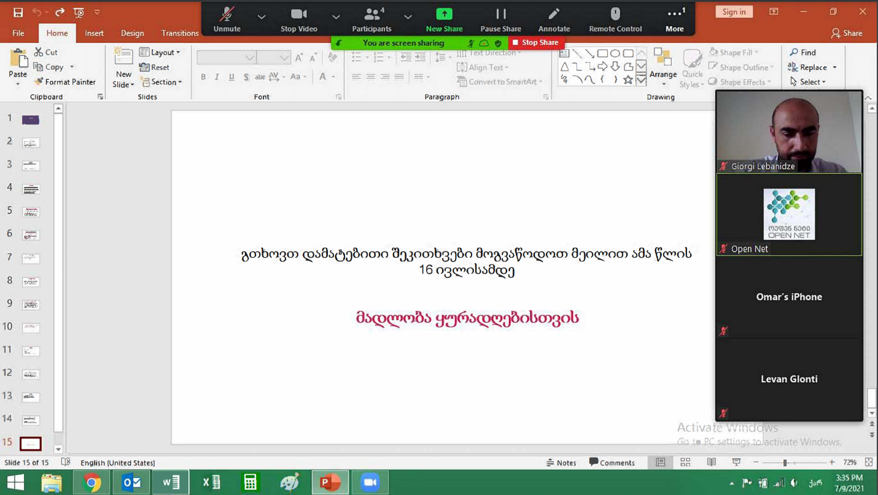

**Webinar screenshot**

**Participants:**

Alexander Tsereteli- Log in Georgia Project Manager, Open Net;

Giorgi Lebanidze – Environmental and Social consultant, Open Net;

Levan Ghlonti – Open Net regional supervisor;

Giorgi Dzidziguri - N system ltd., construction and renovation company;

Builders Group ltd., construction company;

NN Group,construction company.

Minutes of the second public consultation meeting

on draft Environmental and Social Management Plan

August 09, 2021

Additional public consultation meeting on draft Environmental and Social Management Plan (ESMP) was held on August 09, 2021, through zoom communication platform organized by Open Net.

Open Net sent invitation to municipalities, school principals and NGOs operating in the regions. To enhance the involvement of stakeholders the representative of Open Net personally communicated stakeholders and explained the purpose and the importance the stakeholder engagement process. General information about the project has been shared as well.

The virtual meeting was hosted by Open Net and attended by representatives of local NGOs and public schools. At the beginning of the meeting, Open Net representative provided brief information about the objectives, expected results, implementation timeline and geographical coverage of the program, afterwards briefly overviewed the World Bank Environmental and Social Framework (ESF) and Environmental and Social Standards, the requirements of the national legislation of Georgia pertaining the project; then introduced the purpose, structure and requirements of ESMP, focusing on roles and responsibilities of involved parties, grievance redress mechanism, health and safety training, and risk assessment and respective remediation measures.

In the second part of the meeting, time was allowed for a questions-and-answers’ session. The attendees were quite interactive and questions were posed on various components of the program: commencement and completion dates, internet service fees, service providers, and selection criteria for the settlements to be included in the program.

Stakeholder engagement process and regular communication with interest parties will continue throughout the project implementation phase.

Open Net/Supervision Consultant will ensure that the local communities will be communicated on environmental, community health and safety, social/grievance redress issues before the actual commencement of construction works.

Photos and list of participants are attached.

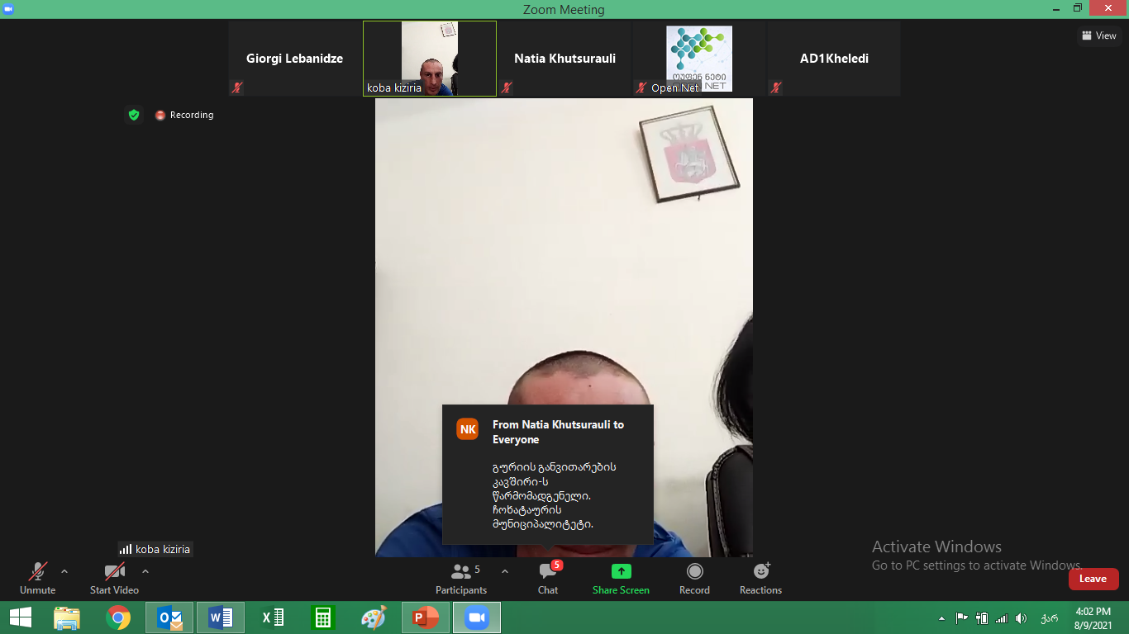

**Webinar screenshot**

**Participants:**

Alexander Tsereteli - Log in Georgia Projects Manager, Open Net;

Giorgi Lebanidze – Environmental and Social consultant, Open Net;

Eldino Liparteliani –Deputy principle on Klehedi Public School, Lentekhi Municipality;

Koba Kiziria – representative of Chokhatauri municipality;

Natia Khutsurauli – Representative of Guria Development Union, local NGO.

1. Land acquisitions includes displacement of people, change of livelihood encroachment on private property this is to land that is purchased/transferred and affects people who are living and/or squatters and/or operate a business (kiosks) on land that is being acquired.
2. Toxic / hazardous material includes but is not limited to asbestos, toxic paints, noxious solvents, removal of lead paint, etc.